nth Pentagonal Number!!

Given an integer n, find the Nth Pentagonal number.

The nth pentagonal number Pn is the number of distinct dots in a pattern of dots consisting of the outlines of regular pentagons with sides up to n dots, when the pentagons are overlaid so that they share one vertex.

Examples:

Input: n = 1

output: 1

Input: n = 4

Output: 22

Input: n = 10

Output: 145

**We strongly recommend you to minimize your browser and try this yourself first.**

**Explanation and Approach: -**

* A **polygonal number** is a [number](https://en.wikipedia.org/wiki/Number) represented as dots or pebbles arranged in the shape of a [regular polygon](https://en.wikipedia.org/wiki/Regular_polygon) .

If *s* is the number of sides in a polygon, the formula for the *n*th *s*-gonal number *P* (*s*, *n*) is

**P (s, n) = ((s-2) *n(n-1) / 2) + n.**

* So, for Pentagonal numbers, we put s = 5 in the above equation, which gives us the routine for finding the nth Pentagonal numbers as shown below.
* **Pn = (3*n2 – n) / 2.**

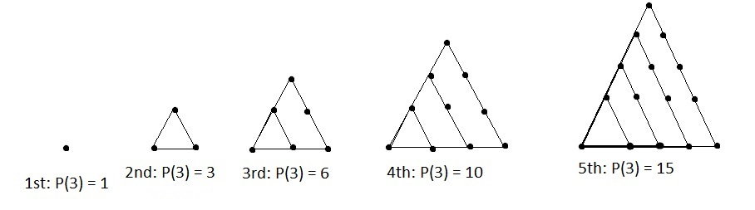

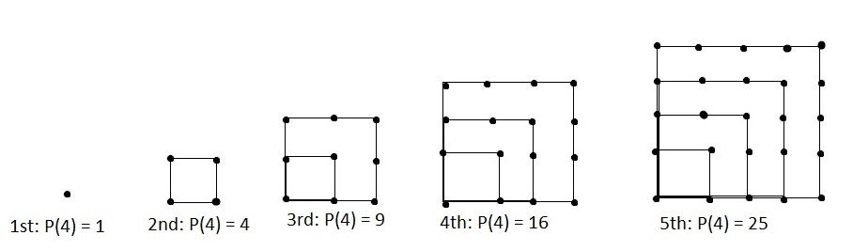

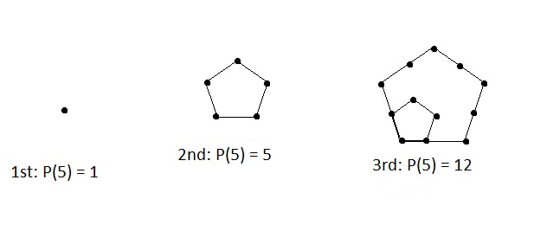

Below is the C implementation of above idea.

// C program for above approach

#include <stdio.h>

#include <stdlib.h>

//Finding the nth Pentagonal Number

**int** Pentagonal_num (int n)

**{**

**return** (3*n*n - n)/2;

**}**

// Driver program to test above function

int main**()**

**{**

int n;

n = 10;

printf(**"nth Pentagonal Number is = %d \n \n",** Pentagonal_num (n) );

**return** 0;

**}**

// JAVA program for above approach

**class** Pentagonal

{

**int** pentagonalNum(int n)

{

**return** (3*n*n – n)/2;

}

}

**public class** GeeksCode

{

**Public static void** main(String[] args)

{

Pentagonal obj = **new** Pentagonal();

**int** n =10;

System.out.printf(**“10th pentagonal number is = “**+obj.pentagonalNum(n));

}

}

//Python code for above approach

**def** pentagonalNum( n ):

**return** (3*n*n - n)/2

#Script Begins

n = 10

print **"10th Pentagonal Number is = "**, pentagonalNum(n)

#Scripts Ends

Output: 145

CONTRIBUTED BY: -

Name: **Mazhar Imam Khan**

My GeeksForGeeks A/C link: http://qa.geeksforgeeks.org/user/Mazhar+MIK

Username: **Mazhar MIK**